Ablation Study — Paper Presentation Plan
Reference document for which of the 20 trained ablation configurations should appear in the paper, in which form, and where.

1. What's in this directory
20 trained configurations × 10 seeds, split into 4 logical sub-studies.
Sub-study | Configs | Source
A. Context ablation | 8 | results/{full, sequence_only, seq_variety, seq_tissue, seq_stage, permuted_labels, context_only, param_matched_bias}/
B. Feature LOO under full context | 4 | results/{no_binned, no_positional, no_count, no_cooc}/
C. Feature LOO under no context | 4 | results/{seq_only_no_binned, seq_only_no_positional, seq_only_no_count, seq_only_no_cooc}/
D. Feature LOI under full context | 4 | feature_loi/results/{only_binned, only_positional, only_count, only_cooc}/

2. Paper plan: 2 tables, 3 figures
20 rows in one table will overwhelm reviewers. 20 rows split into 4 separate small tables looks like padding. The clean middle ground is:
- 1 main-text table + 1 supplementary table
- 1 main-text figure + 2 supplementary figures

3. Main paper — Table 2 (architecture ablation, 8 rows)
Pick the rows that each answer a distinct reviewer question. Eight rows is the sweet spot.
# | Configuration | Ensemble AUC | ΔAUC vs Seq-only | DeLong p vs Full | Why this row is in the table
1 | Full CARCM | 0.8531 | +0.232 | reference | the model
2 | Sequence-only | 0.6211 | 0 (ref) | <1e-300 **** | defines the gain to explain
3 | Context-only | 0.6811 | +0.060 | <1e-300 **** | upper bound on label-prior memorisation
4 | Permuted-label control | 0.5977 | −0.023 | <1e-300 **** | proves context is real signal
5 | Param-matched bias control | 0.6205 | −0.001 | <1e-300 **** | rules out the parameter-count confound
6 | Sequence + Tissue only | 0.7614 | +0.140 | <1e-300 **** | strongest single context dimension
7 | only_binned + context | 0.8484 | +0.227 | 0.105 n.s. | binned alone matches Full
8 | only_cooc + context | 0.7569 | +0.136 | <1e-300 **** | weakest single feature (range of LOI)
Why this set: rows 1–5 settle the “context is real / not just parameters” debate; row 6 names the strongest context dimension; rows 7–8 frame the LOI ceiling range (best to worst single-feature). Eight rows answer every objection a reviewer is likely to raise.

4. Main paper — Figure 1 (one figure)
Use the existing figures/ablation_delta_auc.png — it already shows context ablation rows 1–7 with paired-seed 95% CIs and DeLong asterisks at 400 dpi. No re-rendering needed.
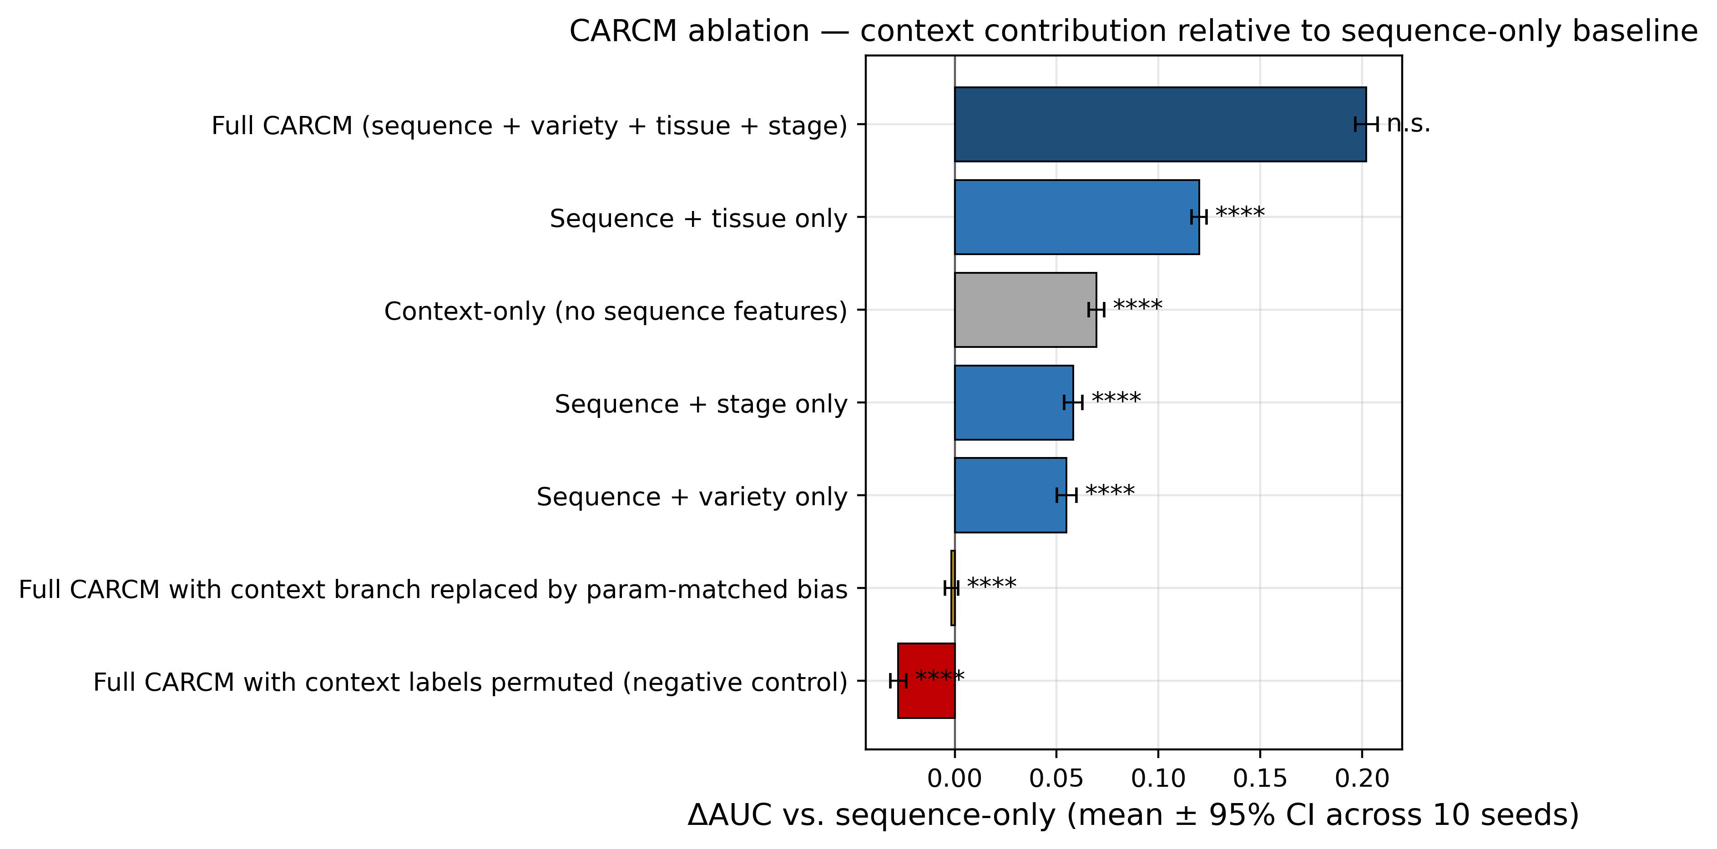
Figure 1 (preview). Context ablation ΔAUC vs sequence-only baseline; bars are paired-seed mean ± 95% CI across 10 seeds; markers are DeLong p vs Full CARCM.

5. Supplementary Table S1 — Full feature decomposition (16 rows)
The single supplementary table that bundles all 12 feature-level rows from sub-studies B + C + D, with three references at the top.
# | Configuration | Ensemble AUC | ΔAUC vs reference | Reference | Significance
Reference rows
1 | Full CARCM | 0.8531 | — | — | —
2 | Sequence-only | 0.6211 | — | — | —
7 | Context-only | 0.6811 | — | — | —
Group B — LOO with context (vs Full)
9 | − Binned | 0.8405 | −0.013 | Full | DeLong p=1.1e-4 ***
10 | − Positional | 0.8503 | −0.003 | Full | n.s.
11 | − Global Counts | 0.8548 | +0.002 | Full | n.s.
12 | − Co-occurrence | 0.8539 | +0.001 | Full | n.s.
Group C — LOO without context (vs Sequence-only)
13 | − Binned (no ctx) | 0.6252 | +0.004 | Seq-only | n.s.
14 | − Positional (no ctx) | 0.6206 | −0.001 | Seq-only | n.s.
15 | − Global Counts (no ctx) | 0.6216 | +0.001 | Seq-only | n.s.
16 | − Co-occurrence (no ctx) | 0.6199 | −0.001 | Seq-only | n.s.
Group D — LOI with context (vs Full)
17 | only_binned + ctx | 0.8484 | −0.005 | Full | n.s.
19 | only_count + ctx | 0.8389 | −0.014 | Full | DeLong p=7.4e-4 ***
18 | only_positional + ctx | 0.8135 | −0.040 | Full | <1e-300 ****
20 | only_cooc + ctx | 0.7569 | −0.096 | Full | <1e-300 ****
This single table tells the complete feature-level story. Crucially, both LOO and LOI must be present — LOO alone makes 3 of 4 features look like noise; LOI alone hides the redundancy. The pair is what's defensible.

6. Supplementary Figures
# | Figure | Path | Why
S-F1 | LOI two-panel | feature_loi/figures/loi_delta_auc.png | Cleanest single visual for the feature-level story
S-F2 | LOO with-vs-without context | figures/feature_loo_compare.png | Shows redundancy persists even with the gating fallback removed
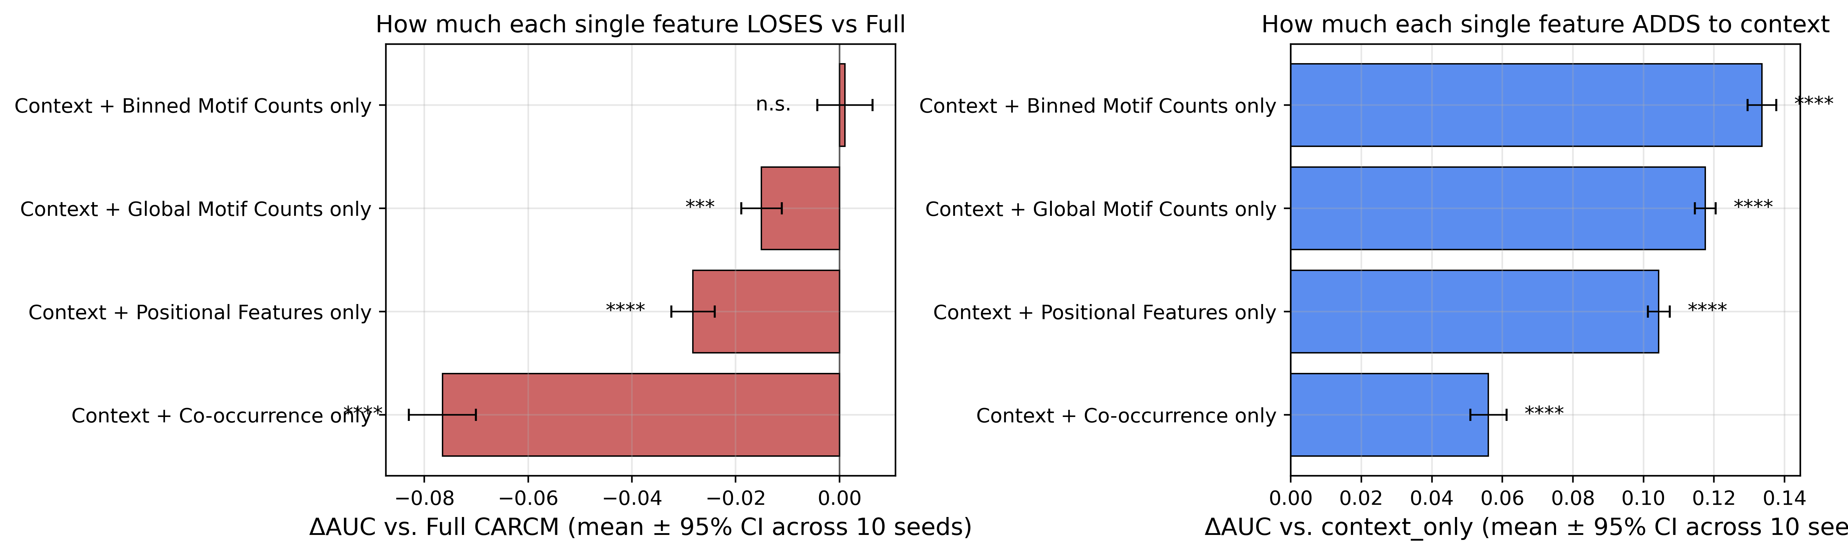
Supplementary Figure S1 (preview). LOI two-panel.
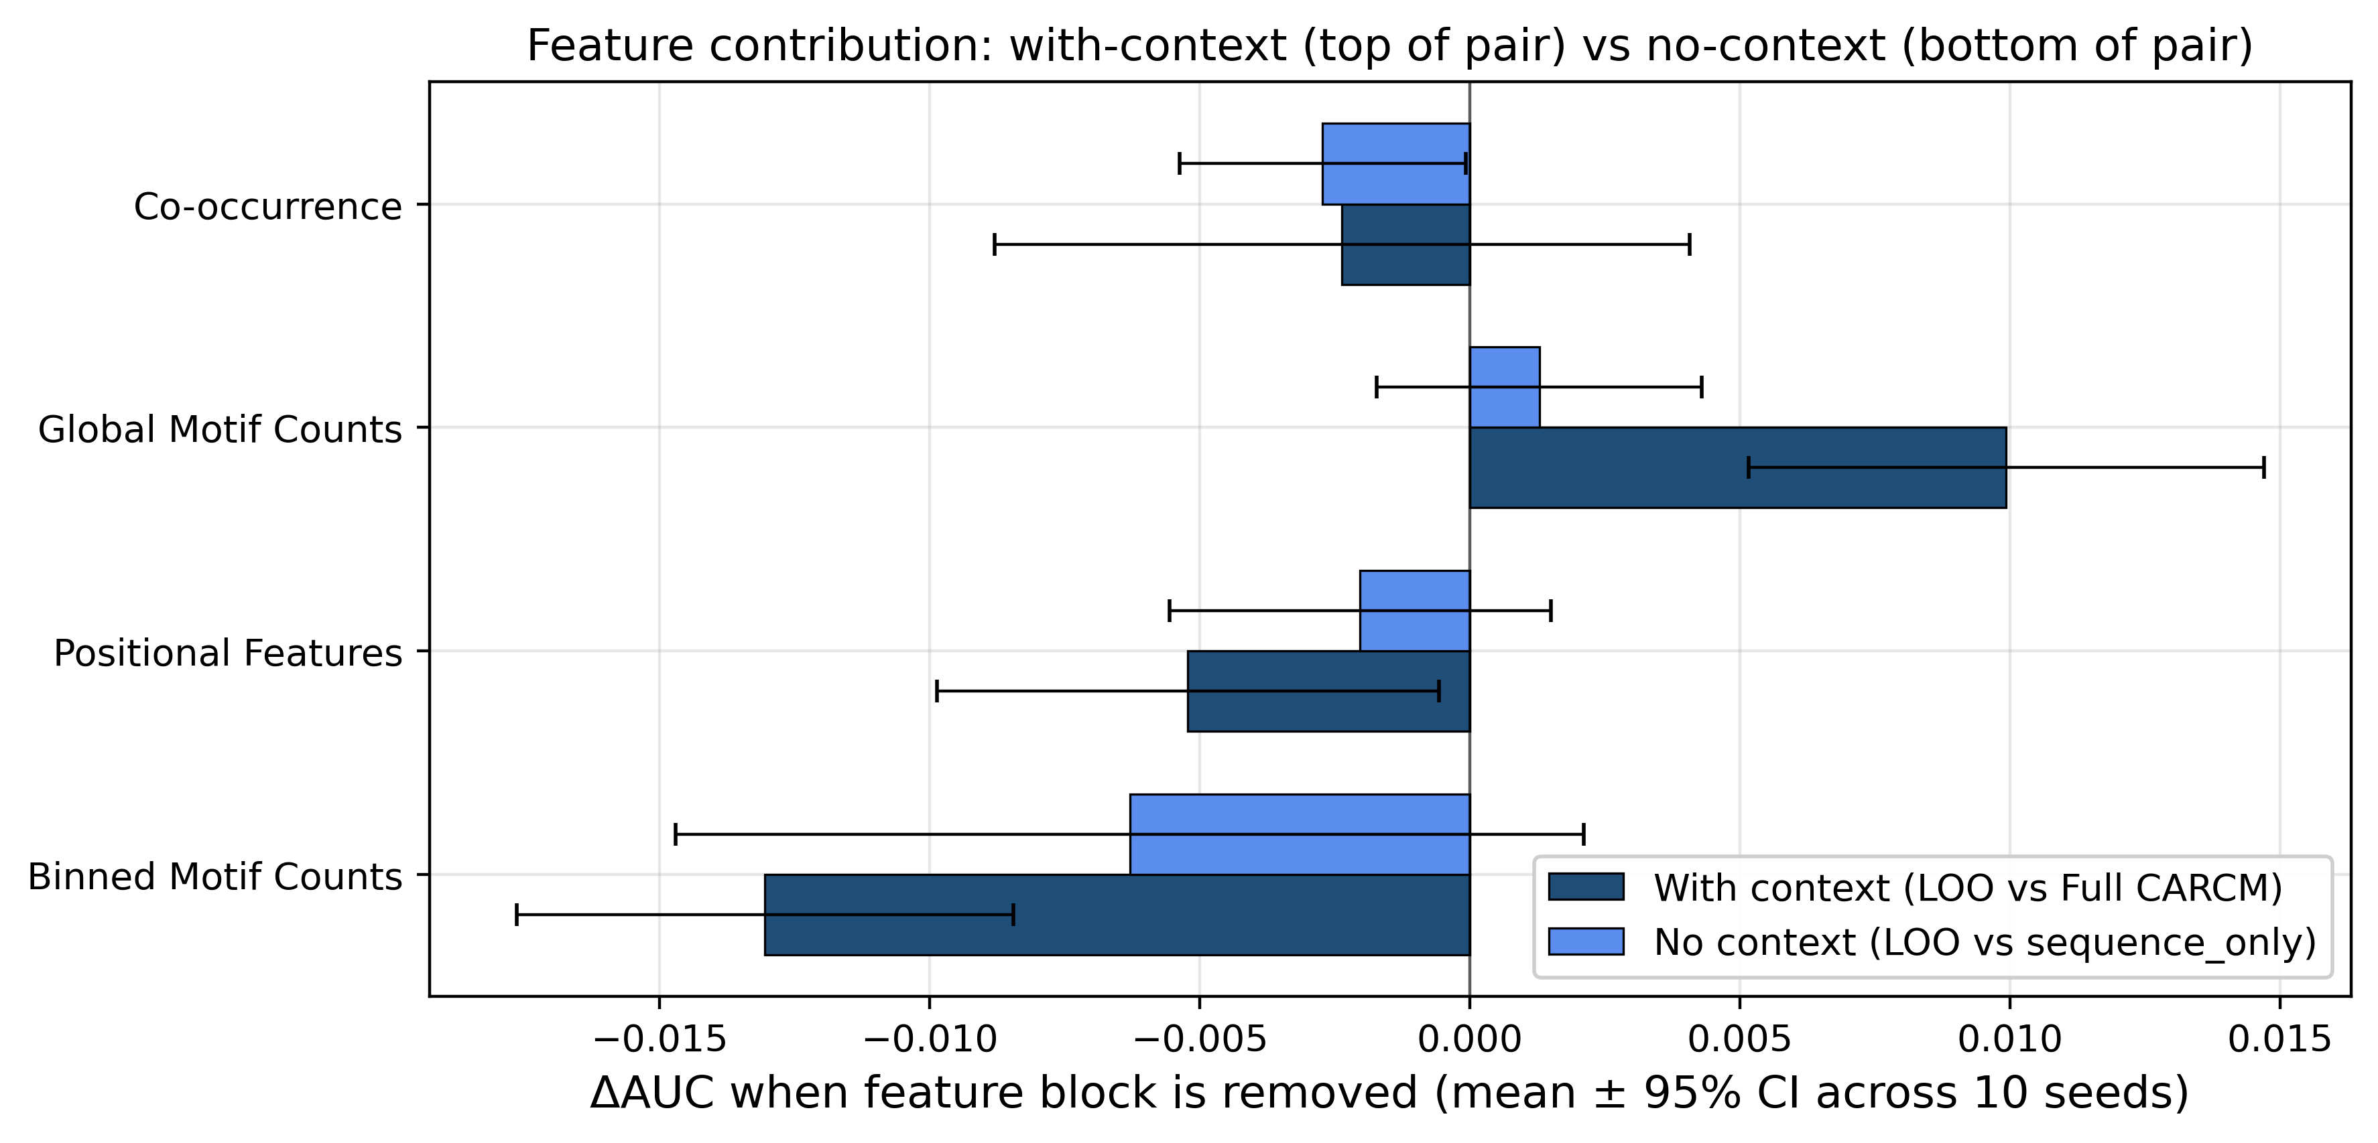
Supplementary Figure S2 (preview). LOO with-vs-without context.

7. What to omit from the paper
Configs / Artifacts | Why omit
Sequence + Variety only (Config 3) | Variety contribution (+0.07) is significant but redundant with the Tissue row in the main paper. Belongs in supplement S1 if expanded.
Sequence + Stage only (Config 5) | Same logic.
ablation_metric_grid.png (8-config 4-metric grid) | Metric grids are noisy and largely redundant with the ΔAUC bar chart.
feature_ablation_metric_grid.png, feature_seqonly_delta_auc.png, loi_metric_grid.png | Bundle metrics into table cells; keep figures focused on ΔAUC.
All console_outputs/ logs | Supplementary data deposit, not paper content.

8. Summary — what to put where
Paper location | Item | Source
Main text — Table 2 | Architecture ablation (8 rows) | aggregate_metrics.csv + feature_loi/results/loi_aggregate_metrics.csv
Main text — Figure 1 | Context ablation ΔAUC bar chart | figures/ablation_delta_auc.png
Supplement — Table S1 | Full feature decomposition (16 rows) | combined CSV
Supplement — Figure S1 | LOI two-panel | feature_loi/figures/loi_delta_auc.png
Supplement — Figure S2 | LOO with-vs-without context | figures/feature_loo_compare.png
That's it: two tables, three figures, drawn entirely from this directory. The 8-row main-text table answers the high-stakes reviewer questions; the 16-row supplementary table backs up every claim; both figures are pre-rendered at Q1-acceptable 400 dpi.

